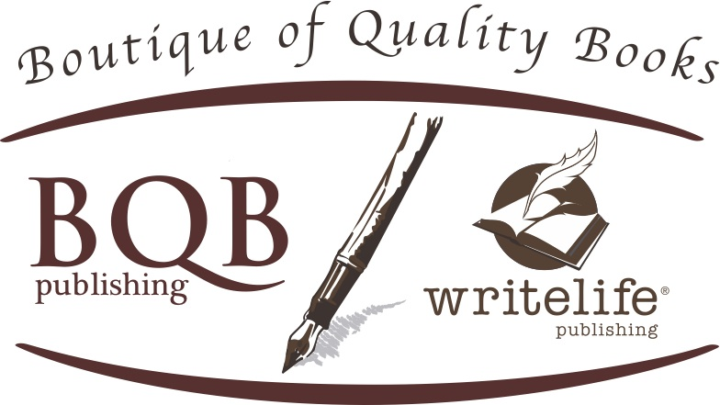
Media Contact:
Terri Leidich
678-316-4150
terri@bqbpublishing.com

BOOK REVIEW INFORMATION

AUTHOR: Helen Pankowsky, MD

TITLE: Living Aware & Inspired: Intuition, The Bioenergy Field, Mind, and Emotions

PUBLISHER: WriteLife Publishing (an imprint of Boutique of Quality Books Publishing)

PUBLISHER CONTACT INFORMATION: Terri Leidich

PUBLISHER ADDRESS: 960 Oaktree Blvd, Christiansburg, VA 24073

PUBLISHER PHONE #: 678-316-4150

DISTRIBUTOR: IPG, www.ipgbook.com

DATE OF PUBLICATION: January 1, 2019

INTENDED AUDIENCE: Adult

CATEGORY: Body, Mind, Spirit/Personal Growth

PRINT PRICE: US $16.95; CANADA $20.95 EBOOK PRICE: US $5.99; CANADA $8.99

NUMBER OF PAGES: 268

ISBN: 978-1-60808-207-0 (p); 978-1-60808-208-7 (e)

LCCN: ordered

Illustrations, Appendix, and Bibliography Included

