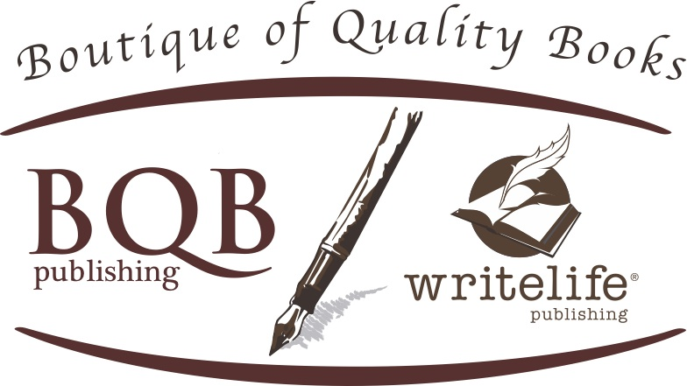
terri@bqbpublishing.com
www.bqbpublishing.com
678-316-4150

Biography for Helen Pankowsky, M.D.

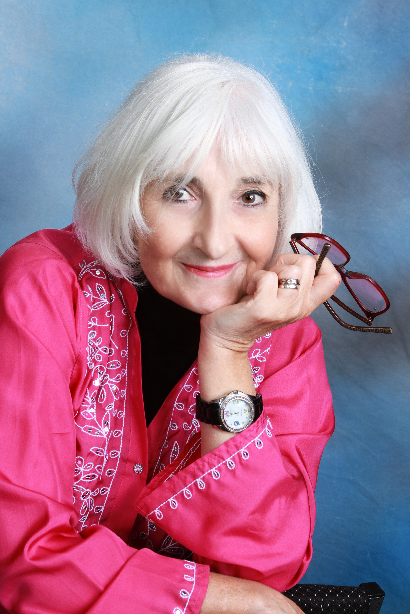
Helen Pankowsky, M.D. works as a psychiatrist who is known for using cutting edge modalities that integrate traditional medicine with alternative methods, successfully combining medications (as little as possible) with psychotherapy, kinesiology, energy healing, holistic lifestyle education, and intuition. Dr. Pankowsky has been a Jungian based therapist, is certified in Eye Movement Desensitization and Reprocessing (EMDR), is certified in Transcutaneous Acupuncture, and has studied alternative and complementary medicine and intuition extensively. She is a Reiki master (RMT) and a long-time practitioner of Tai Chi and Qi Gong. She has lectured and taught classes on Intuition, the Feminine Psyche, Dreams, Kinesiology for Accessing Inner Blocks, Bioenergy, Emotions and the Body, Sophia (The Wisdom of God) and the Psyche, and On Becoming the Authentic Self. She has also done presentations on Gender Discrimination, Inspiring Women, Motherhood, Cancer and the Bioenergy Field, and Treatments for Post Traumatic Stress Disorder. Passionate about understanding the essence of healing, she is committed to answering the questions, "what makes our life meaningful, how do we manifest our highest capacity, and how do we find peace with who we are and the life we have?" She is dedicated to making these ideas, skills, and possibilities for expanded consciousness available to all.

Helen lives in San Antonio, Texas with her husband where she often looks out the window at the trees, birds, and creatures, writes poetry, creates art, does as much tai chi and qi gong as possible, and where she still works healing patients toward their wellbeing.

