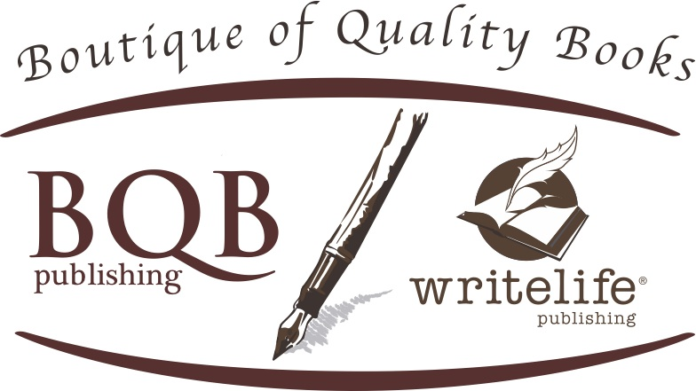
FOR IMMEDIATE RELEAS4E
Media Contact:
Terri Leidich
P: 678-316-4150
terri@bqbpublishing.com

An easy to understand and accessible guide for becoming aware of the unity of body, intuition, mind, and emotions.
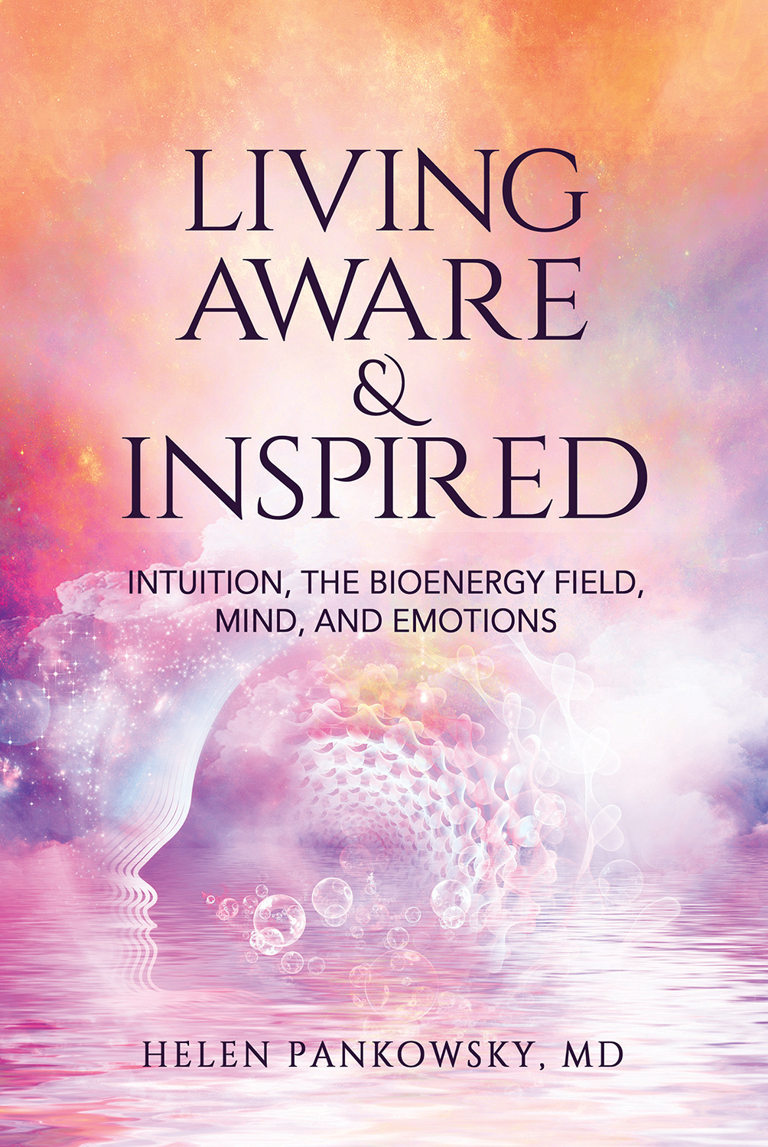

An inspired life means living to your highest potential --- having a healthy body, a creative mind, the ability to take full responsibility for your choices, embracing who you are, and connecting to your spiritual life.

Yet, a lot of us who desire to live to our highest potential don’t have an idea of where to start. In her book Living Aware & Inspired, Helen Pankowsky, MD teaches us how. How to strengthen and trust our intuition. How to feel, test, and balance our energy flow. And how to understand our emotions, where they come from, where they are blocked, and how to resolve those blocks.

Dr. Pankowsky is a practicing psychiatrist who is known for using cutting edge modalities that integrate traditional medicine with alternative methods, successfully combining medications (as little as possible) with psychotherapy, kinesiology, energy healing, holistic lifestyle education, and intuition. In her book Living Aware & Inspired she provides accessible and easy to understand information along with exercises and illustrations to guide readers on a path of living a fuller, more realized, and inspired life, a goal many of us aspire to achieve.

ABOUT THE AUTHOR:

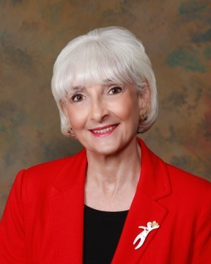
Dr. Pankowsky has been a Jungian based therapist, is certified in Eye Movement Desensitization and Reprocessing (EMDR), is certified in Transcutaneous Acupuncture, and has studied alternative and complementary medicine and intuition extensively. She is a Reiki master (RMT) and a long-time practitioner of Tai Chi and Qi Gong.

She has lectured and taught classes on Intuition, the Feminine Psyche, Dreams, Kinesiology for Accessing Inner Blocks, Bioenergy, Emotions and the Body, Sophia (The Wisdom of God) and the Psyche, and On Becoming the Authentic Self. She has also done presentations on Gender Discrimination, Inspiring Women, Motherhood, Cancer and the Bioenergy Field, and Treatments for Post Traumatic Stress Disorder.

Passionate about understanding the essence of healing, she is committed to answering the questions, "what makes our life meaningful, how do we manifest our highest capacity, and how do we find peace with who we are and the life we have?" She is dedicated to making these ideas, skills, and possibilities for expanded consciousness available to all.

Helen lives in San Antonio, Texas with her husband where she often looks out the window at the trees, birds, and creatures, writes poetry, creates art, does as much tai chi and qi gong as possible, and where she still works healing patients toward their wellbeing.

About Boutique of Quality Books Publishing Company, Inc.
Founded in August of 2010, Boutique of Quality Books Publishing was created to be “the writer’s publisher,” focusing on quality writing from new authors in both fiction and nonfiction genres. An independent publisher, Boutique of Quality Books, under its two imprints—BQB Publishing and WriteLife Publishing—combines the quality processes of traditional publishing with hands-on author involvement to bring today’s new writers and tomorrow’s best sellers into the hands of booksellers and the reading public. www.bqbpublishing.com www.writelife.com

All books published by Boutique of Quality Books Publishing Company, Inc., and its two imprints —BQB Publishing and WriteLife Publishing—are distributed by IPG www.ipgbooks.com

